**COCO MADEMOISELLE**

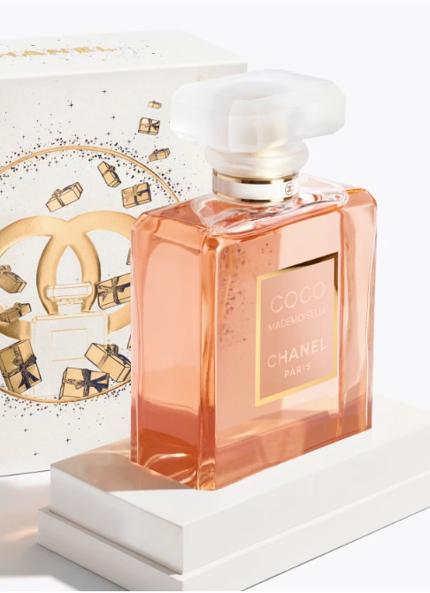**Eau de Parfum Spray**

**Product**

Irresistibly sensual, irrepressibly spirited. A sparkling, bold ambery fragrance that recalls a daring young Coco Chanel. An absolutely modern composition with a strong yet surprisingly fresh character.  
  
A double name, a double personality. Independent and endearing, mischievous and provocative, light and exuberant. The expression of a woman free to reinvent herself day after day.

**Composition**

Vibrant orange immediately awakens the senses. A clear and sensual heart reveals a transparent accord of jasmine and May rose. The scent finally unfurls with refined accents of patchouli and vetiver.

**Art of perfuming**

The Eau de Parfum comes in a spray for easy application.